We Will have the Sites Page like this <https://www.landmarknsw.com.au/site>

It will have a calendar which will show scheduled tasks when we open the page – Week View by default

Then when you click on one site it will open this page <https://www.landmarknsw.com.au/site/80-ninth-ave%2C-austral>

I want to show here all the docs = normally PDFs for this project like this 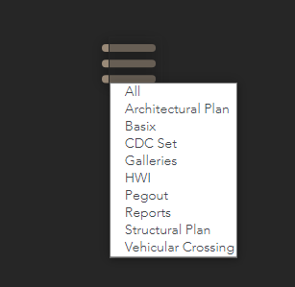

I want to show all the contacts too somewhere below the hero picture like this below

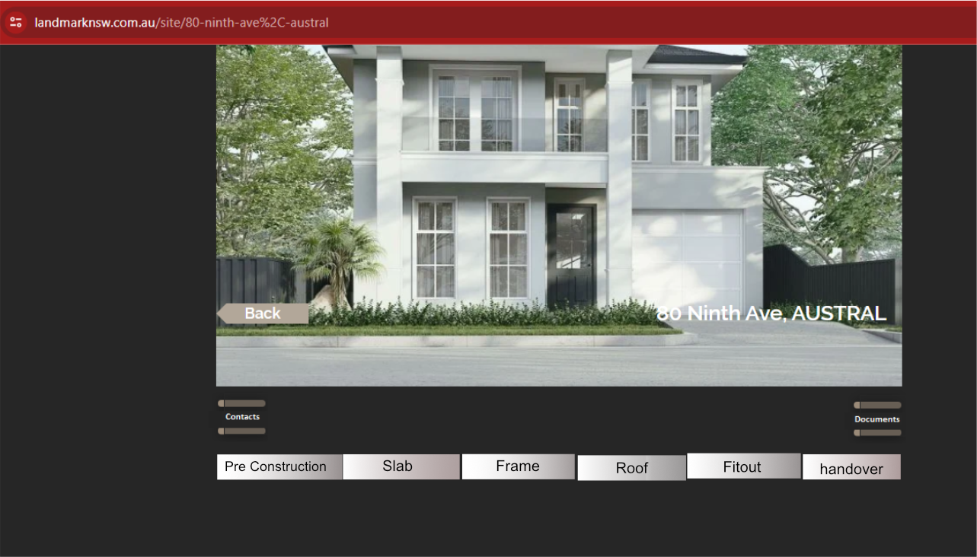

Show the checklists as

per below

·

Filtered

by Stages

·

In certain

order

·

Add a

field on DB to allow to add any new checklists in the future and rearrange the

order if necessary (sorting) from admin panel. Example – Checklist 112 – I

may have to move up to appear before 95. OR I may now add a new checklist and

instead of this showing at the end – I may have to show it at the 2nd

number of First stage and so on

·

Supervisor

will complete the checklist by any or all of below

§ Add comment and Submit

§ Add photo Video and submit

§ Add Comment and select a date on calendar to

schedule a job for future date and Submit. (This scheduled job will show on the

main calendar on the main page, which will be marked completed /add details or

reschedule if needed)

§ OR Some or all of above.

o

Once a

task is completed and submitted

§ Data submitted will show on that panel as a

read ONLY

§ Will have an EDIT Button to allow editing and

resubmit

§ Record and show the logs by WHO updated WHAT

and WHEN – this can be collapsible and open only when clicked

§ Photos/videos Thumbnails to show on each task

containers.

§ Show Photos/videos them on a bigger view on the

gallery at the bottom of the page

§ By default the latest pending task will appear

first. The past and Future tasks will be only accessible

by scrolling up or down