We Will have the Sites Page like this https://www.landmarknsw.com.au/site
It will have a calendar which will show scheduled tasks when we open the page – Week View by default

Then when you click on one site it will open this page https://www.landmarknsw.com.au/site/80-ninth-ave%2C-austral
I want to show here all the docs = normally PDFs for this project like this 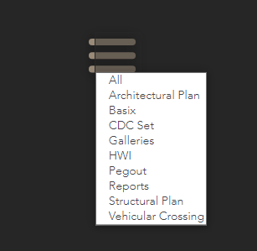

I want to show all the contacts too somewhere below the hero picture like this below
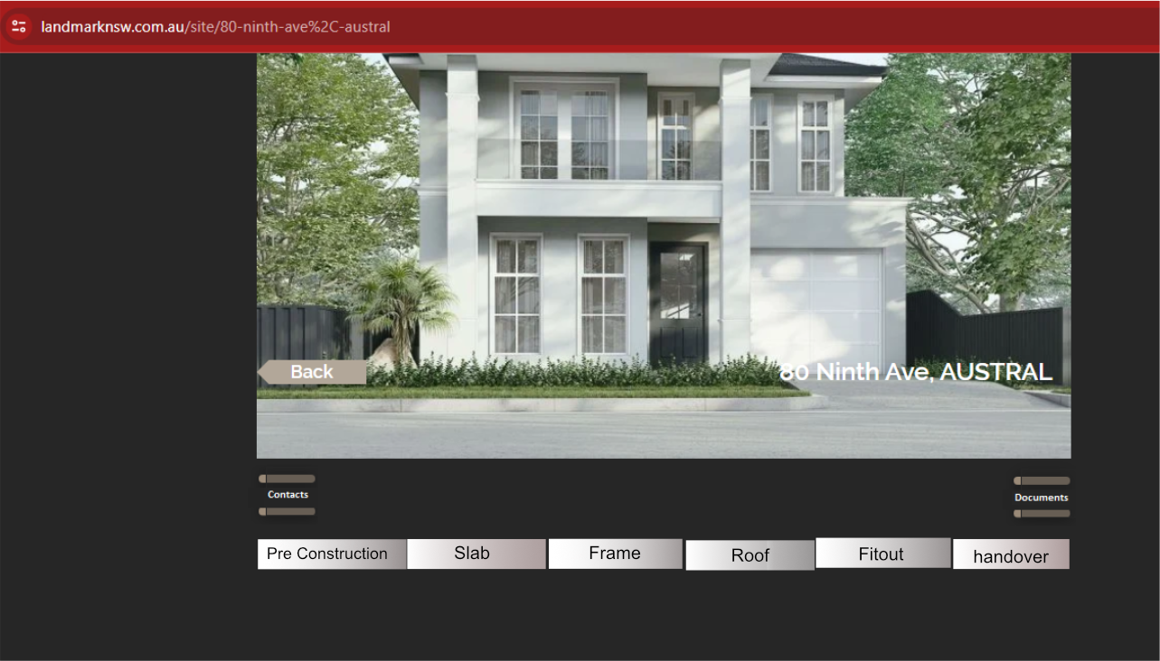

Show the checklists as
per below

·
Filtered
by Stages

·
In certain
order

·
Add a
field on DB to allow to add any new checklists in the future and rearrange the
order if necessary (sorting) from admin panel. Example – Checklist 112 – I
may have to move up to appear before 95. OR I may now add a new checklist and
instead of this showing at the end – I may have to show it at the 2nd
number of First stage and so on

·
Supervisor
will complete the checklist by any or all of below

§ Add comment and Submit

§ Add photo Video and submit

§ Add Comment and select a date on calendar to
schedule a job for future date and Submit. (This scheduled job will show on the
main calendar on the main page, which will be marked completed /add details or
reschedule if needed)

§ OR Some or all of above.

o
Once a
task is completed and submitted

§ Data submitted will show on that panel as a
read ONLY

§ Will have an EDIT Button to allow editing and
resubmit

§ Record and show the logs by WHO updated WHAT
and WHEN – this can be collapsible and open only when clicked

§ Photos/videos Thumbnails to show on each task
containers.

§ Show Photos/videos them on a bigger view on the
gallery at the bottom of the page

§ By default the latest pending task will appear
first. The past and Future tasks will be only accessible
by scrolling up or down

