We Will have the Sites Page like this <https://www.landmarknsw.com.au/site>

It will have a calendar which will show scheduled tasks when we open the page – Week View by default

Then when you click on one site it will open this page <https://www.landmarknsw.com.au/site/80-ninth-ave%2C-austral>

I want to show here all the docs = normally PDFs for this project like this 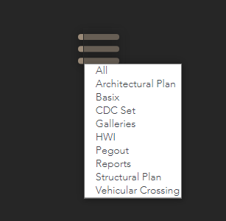

I want to show all the contacts too somewhere below the hero picture like this below

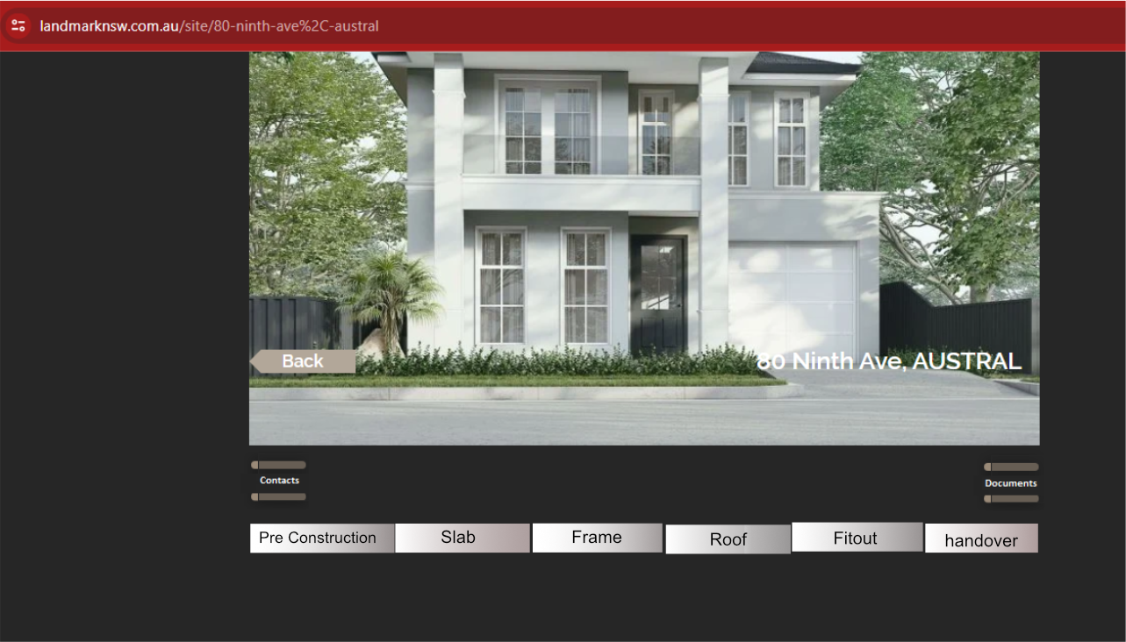

The checklists will be uploaded on the DB via admin using Excel Sheet

The tab format will be

ID – Checklist – Stage

Example

1 – Clean the Site - pre Construction

35 – Inspection by Certifier – Frame

…….

Show the checklists as

per below

Checklilst ID (eg 1, 2, 3….) Checklist text (Eg clean the site)

Take / upload photo

Comment Box

Calendar to schedule a task for future date

Submit

·

Record who submitted and what

Once submitted – the supervisor or admin can edit if required but all edit history recorderd with time stamp

\*\* So every checklist will have one form view ( for before submission)

And another submission view – which will show what was submitted and picture thumbnails etc

All these checklists are

Filtered

* by Stages (eg – pre construction stage will show only the checklists for the preconstruction stage)·
* In certain order eg – ascending order as per the checklist ID – 1 – 2 -3 -4 ………….

·

Add a

field on DB to allow to add any new checklists in the future and rearrange the

order if necessary (sorting) from admin panel. Example – Checklist 112 – I

may have to move up to appear before 95. OR I may now add a new checklist and

instead of this showing at the end – I may have to show it at the 2nd

number of First stage and so on

·

Supervisor

will complete the checklist by any or all of below

§ Add comment and Submit

§ Add photo Video and submit

§ Add Comment and select a date on calendar to

schedule a job for future date and Submit. (This scheduled job will show on the

main calendar on the main page, which will be marked completed /add details or

reschedule if needed)

§ OR Some or all of above.

o

Once a

task is completed and submitted

§ Data submitted will show on that panel as a

read ONLY

§ Will have an EDIT Button to allow editing and

resubmit

§ Record and show the logs by WHO updated WHAT

and WHEN – this can be collapsible and open only when clicked

§ Photos/videos Thumbnails to show on each task

containers.

§ Show Photos/videos them on a bigger view on the

gallery at the bottom of the page

§ By default the latest pending task will appear

first. The past and Future tasks will be only accessible

by scrolling up or down